This document contains the details on how to install a Global Research Platform certificate, for the current user, on OSX. The certificate will only work for the user currently logged into the Macintosh computer. All other user accounts will require a new certificate and to complete the following instructions.

**Instructions:**

1. Request a certificate from the Global Research Platform public site.
2. Once you have obtained a certificate, open your keychain utility. To achieve this open the Finder *Go* menu item and select *Utilities*.

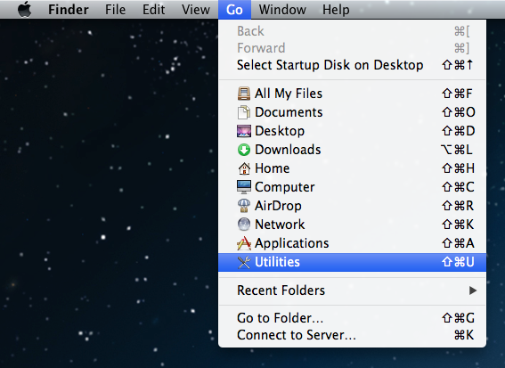

1. In the *Utilities* folder find and double click *Keychain Access*.

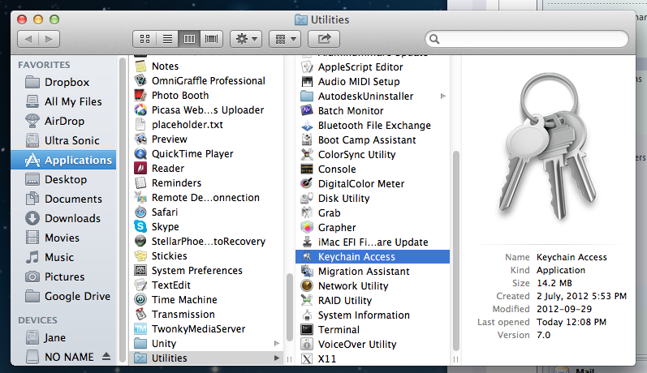

1. Expand the File menu item and select *Import Items…*

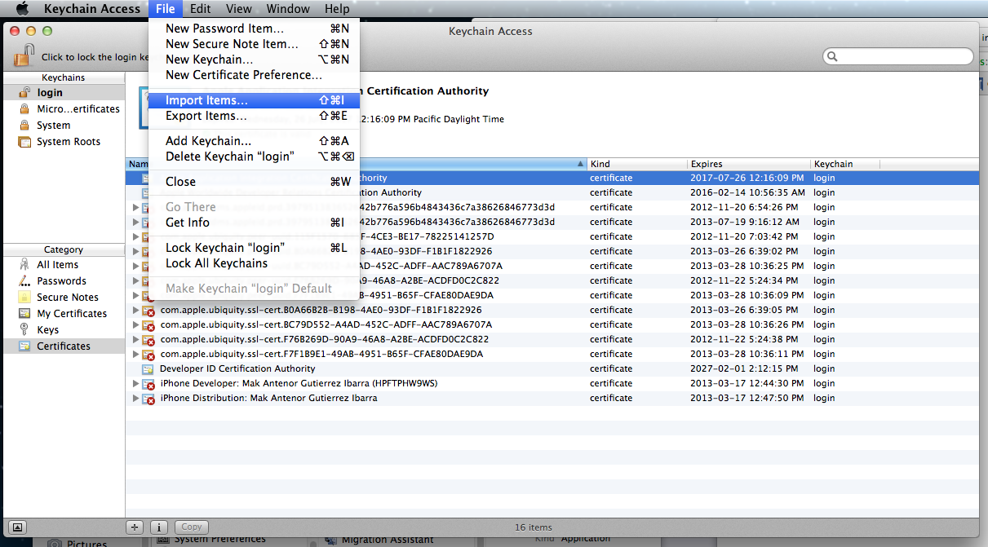

1. Navigate to the folder containing your certificate and open it. You will now see the RHIGRP certificate in your login keychain. Most likely the certificate will display a red “x” icon. This means the certificate is not trusted.

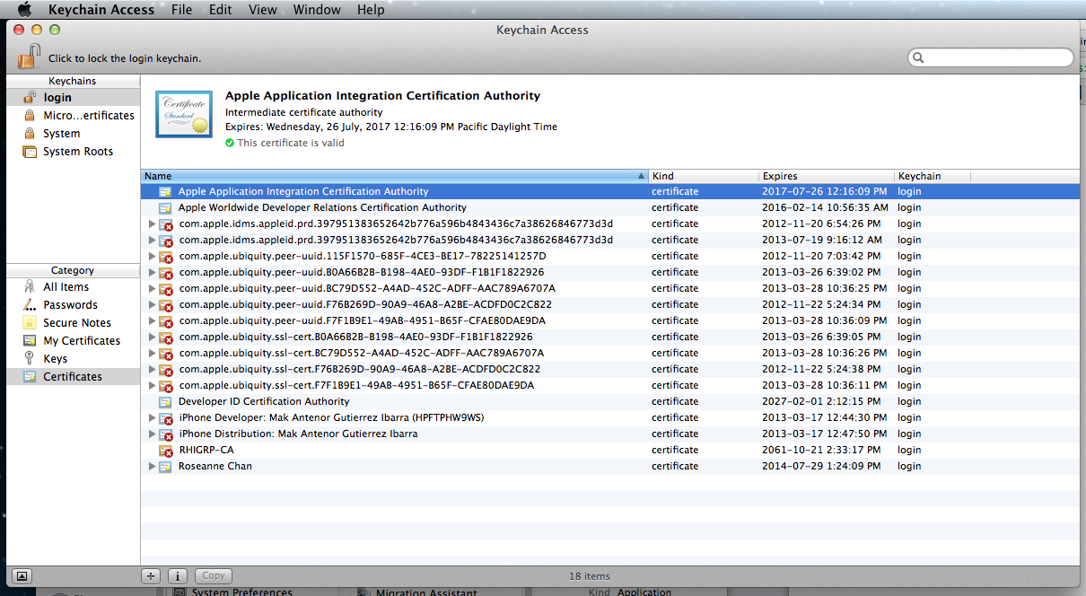

1. Give your certificate full trust by double-clicking the RHIGRP-CA certificate and selecting *Always Trust* under the *When using this certificate* dropdown.

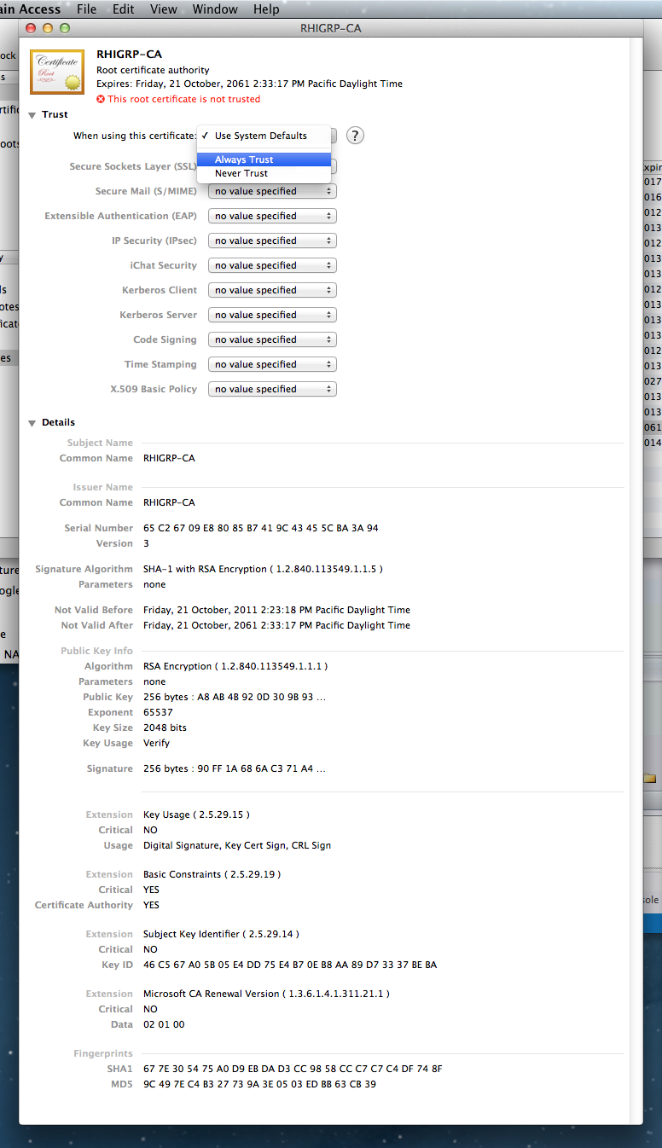

1. Your certificate should show a blue icon with a plus sign, instead of the red icon with an “x”.

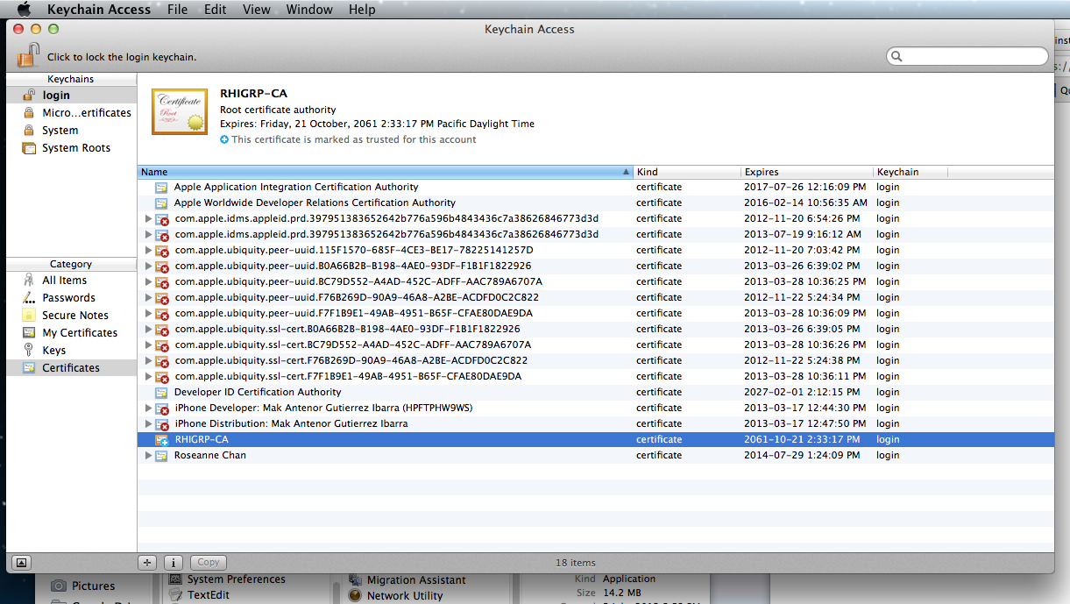

1. Test your certificate. Open Safari and navigate to <https://secure.rhigrp.net/> Safari will display a dialog informing you that the site requires a client certificate. Select the RHIGRP-CA certificate and click on the *Continue* button.

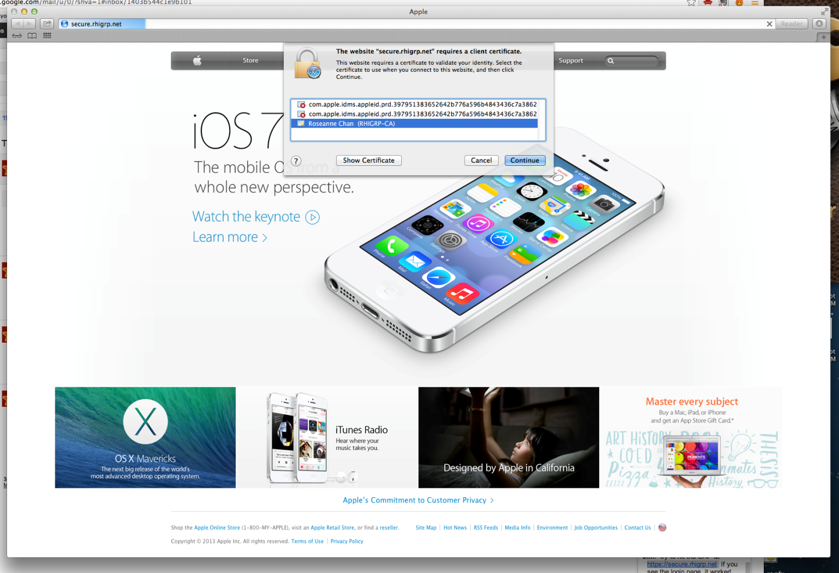

1. Safari will now ask you to confirm the certificate. Select *Always Allow*.

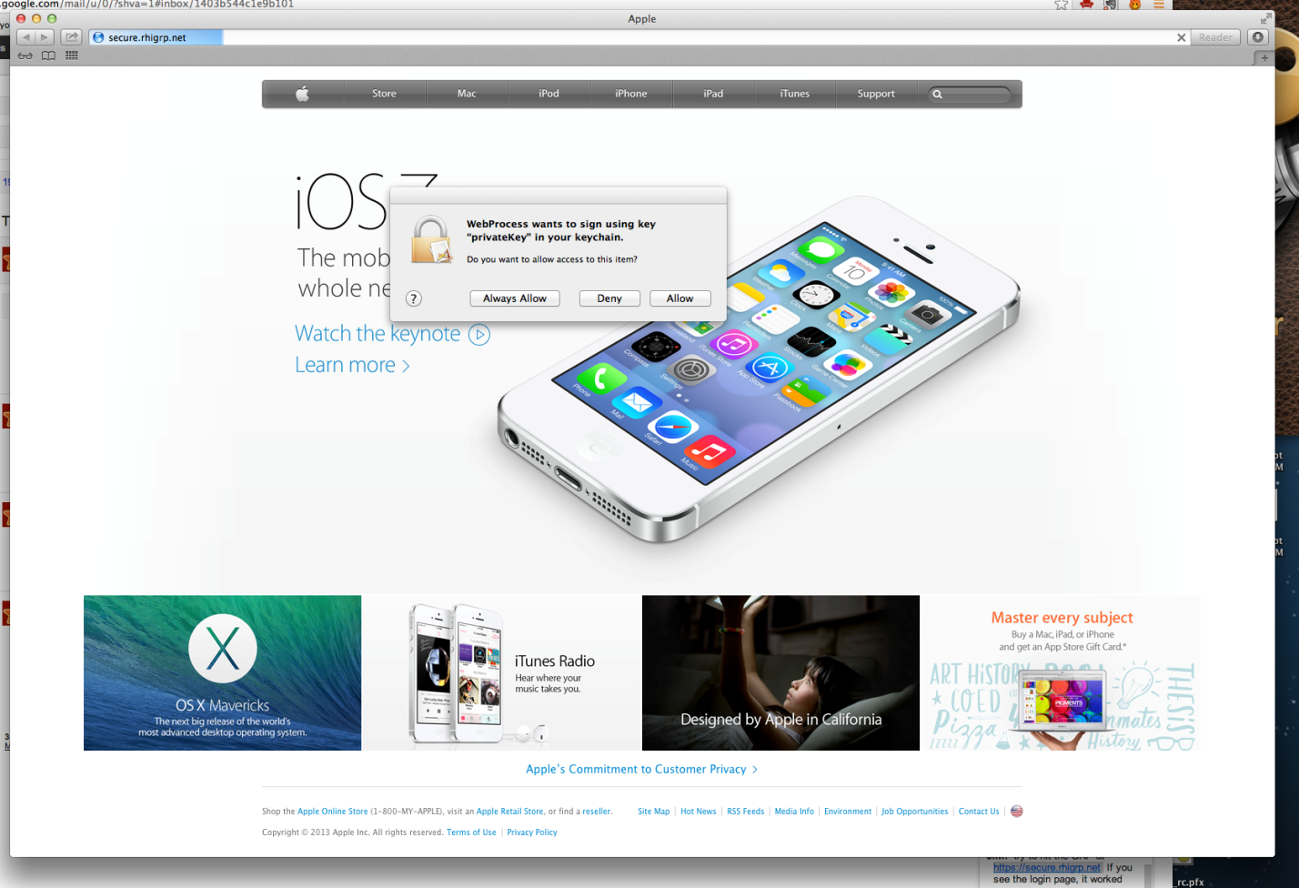

1. If you prefer to use Chrome, open your Chrome web browser and navigate to <https://secure.rhigrp.net/> Chrome will also ask you to select a certificate for this site. Select your RHIGRP-CA certificate and click *OK*.

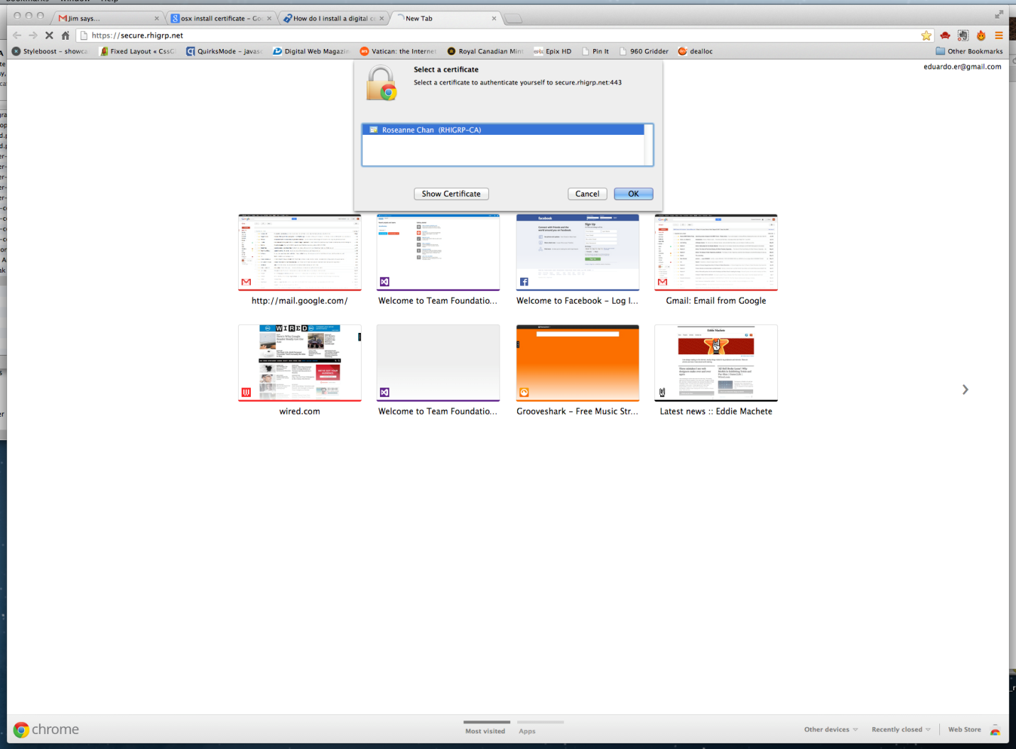

1. Chrome will now ask you to confirm this certificate. Click on the *Always Allow* button.

